Following are recommendations on how to use ‘gcovr’ without python installation -
- Set Path of python folder from Tools generic in environment path variable.
- Set GCC compiler path (which includes gcov) from tools generic to environment path variable
- Please use following command to run gcovr, below are examples –
  - Command line output
C:\ALGitRepos\gcovr_test\build>python C:\ALGitRepos\ToolsGeneric\Utilities\CommonDomain\python\python383\Lib\site-packages\gcovr\gcovr.py -r../ --object-directory ../obj

  - HTML output:
C:\ALGitRepos\gcovr_test\build>python C:\ALGitRepos\ToolsGeneric\Utilities\CommonDomain\python\python383\Lib\site-packages\gcovr\gcovr.py -r../ --object-directory ../obj --html-details index.html
Where:
- Git repository paths needs to be adjusted in build environment accordingly.
- Build folder structure used for example above is as below:
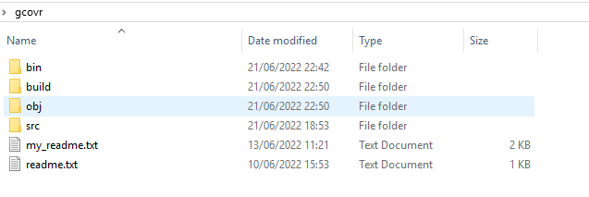
- Below are commands to compile and prepare the build for gcovr in above structure:
  - g++ -x c++ -c -Wall -Wextra -O3 -fprofile-arcs -ftest-coverage ../src/test.cpp -o ../obj/test.o
  - g++ -Wall -Wextra -O3 -fprofile-arcs -ftest-coverage ../obj/test.o -o ../bin/test.exe
  - ..\bin\test.exe

