How to Run MISRA-QAC batch files
There are several forms of MISRA support that are included in the build of the project. These include:
- Run QAC analysis batch files manually
- Run CI scripts to produce MISRA summary information
- *EXPERTS* Run the QAC GUI project as an expert and view the results. This can be helpful for detailed reviewing.

HOWTO: Run the QAC analysis batch files manually
1.0 |  | Create QAC batch files
After we build the project, three batch files are created below the path.
Our example in this documentation will be Asr6.
The path of the batch files depends on the build configuration.
Example:
…\Asr6\Build\Tmp\F0Bw16_App_default\qac

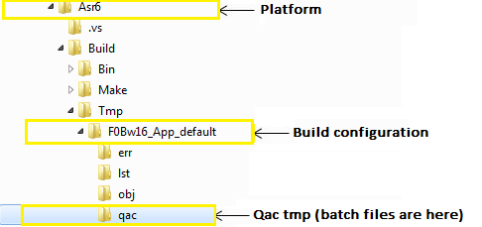

There are three (optional) batch files example based on F0Bw16_App_default):
- . _F0Bw16_App_default_qac_QAC-8.1.2-R_analyze.bat
- . _F0Bw16_App_default_qac_QAC-8.1.2-R_report.bat
- . _F0Bw16_App_default_qac_QAC-8.1.2-R_view.bat

Each one of these batch files has a different purposes and can be used for expert analyses. See the descriptions below.

2.0 |  | Run:  _F0Bw16_App_default_qac_QAC-8.1.2-R_analyze.bat
 |  | This batch file runs QAC analysis on all source files in the configuration. This batch file should be run as first, because this makes the analysis and generates some summary, which include warnings, dataflow problems, software defects, and language implementation errors.
3.0 |  | Run:  _F0Bw16_App_default_qac_QAC-8.1.2-R_report.bat
This batch file creates QAC MISRA reports.
(You must first run *_analyze.bat shown above).
These reports help to find problems, showing where to get a better look and identifying areas where the most work is needed.
Compliance Report: Shows areas that need more improvement to get a higher level of compliance.
Code Review Report: suitable for peer-review enabling design, optimization and requirements
Metric Data Report: Provides an XML file as a source for quality metrics.
Suppression Report: shows discrete information about diagnostic messages that were suppressed throughout the analysis
4.0 |  | Run:  _F0Bw16_App_default_qac_QAC-8.1.2-R_view.bat
(You must first run *_analyze.bat shown above).
This batch file calls the message browser, which is shown into three panes:
Warning Summary View: shows various groupings of encountered messages.
Source View: shows annotated source code for the first or highlighted messages occurrence, and, in a second tab, the HTML explanation file for the selected message.
Warnings List View: details the listing of messages instances according to the summary View selection.

HOWTO: Run CI scripts to produce MISRA summary information
- Consider the Directory “CI”
CI means “Continuous Integration”
- Here you will find a subdirectory called “Support”
- Are you interested in MISRA and Test Statistics?
Then run “run_qac.bat” and “report_integration.bat”
- These will generate summary information for QAC analysis and unit tests.
These batch files analyzes the existing builds that have been run on the machine.
Example of:
Running run_qac.bat” and “report_integration.bat”
- Find the file “CI\Support\run_qac.bat
- And run it.
Example:
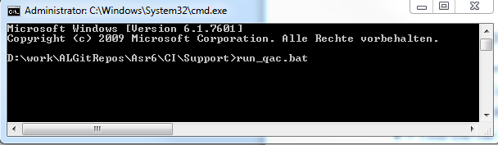
Example output:
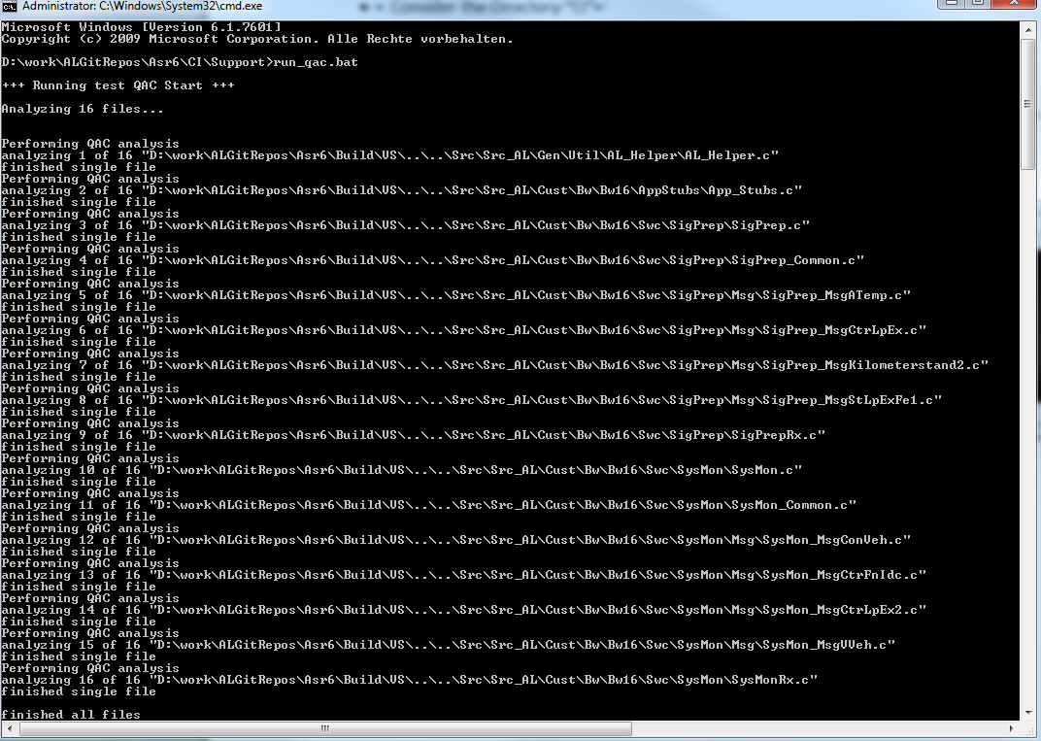

- Find the file “CI\Support\report_integration.bat
- And run it.
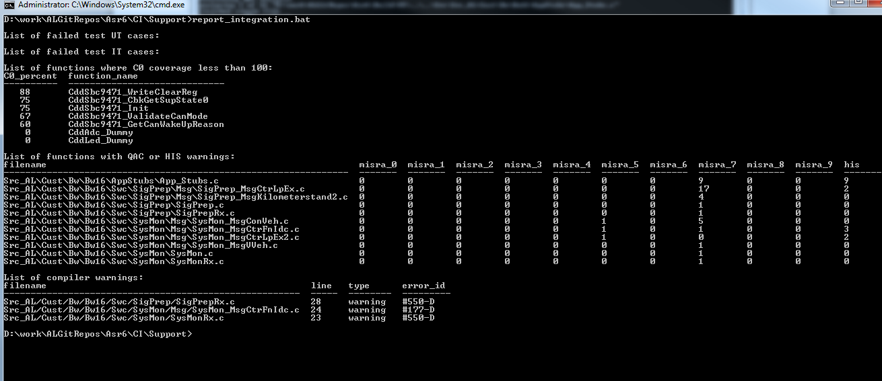

HOWTO: *EXPERTS* Run the QAC GUI project as an expert and view the results
- Experts might want to run QAC themselves to look at analysis of MISRA.
- Run the QAC GUI.
- Open the project file “…\Build\Tmp\F0Bw16_App_default\qac\_qac_gui.prj”
Example of:
Running QAC GUI with “\_qac_gui.prj”

