Index
1. Introduction 2
2. TRACE32 installation set up 3
3. FLM3 TRACE32 startup environment 12
4. Flashing of the Traveo-II device 14
5. Debugging 17

Introduction

This document provide you a step-by-step manual on installation of TRACE32 debug environment. At the end of the document, you can find some FLM3 project specific information.

TRACE32 installation set up

- Step 1: If it is the first time you install TRACE32 software on your machine proceed as follow. Otherwise, if you already have an existing TRACE32 software installed in C:\T32 then you can go directly to step 4.

- Step 2: copy and unzipped locally (ex: D:\Temp) on your machine the file TRACE32_R_2019_09_000114442.7z (\\dereu1nquest1\install\Tools\Lauterbach\Updates\2019_12_16_Release_R_2019_09.000114442\)

- Step 3: execute setup.bat and follow the installation process step by step.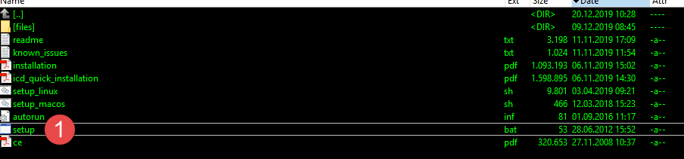
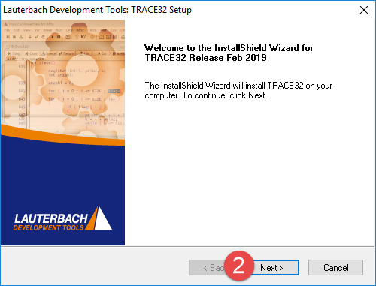
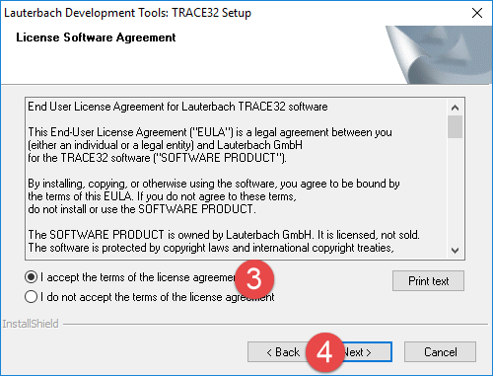
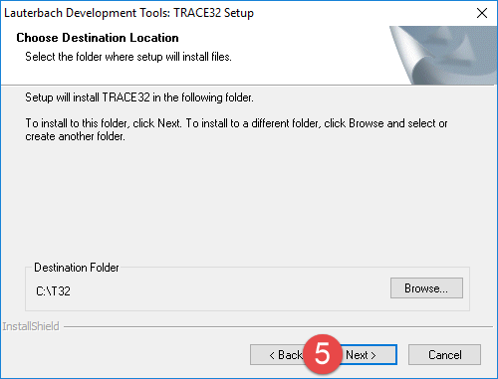
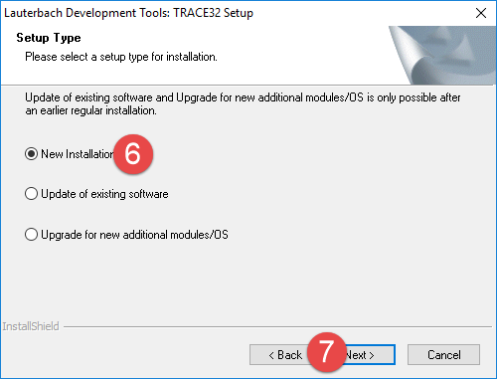
You can choose your hardware to install automatically the USB drivers. (Most FLM3 developers will use µTrace harwarde).
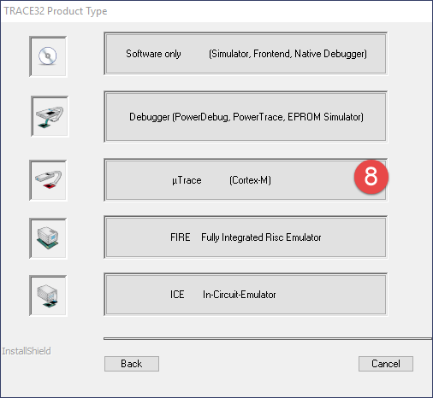
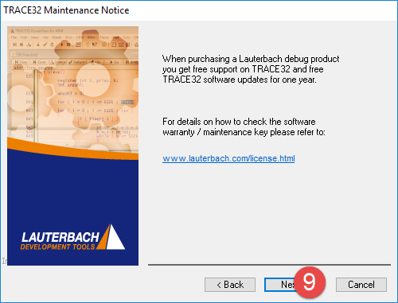

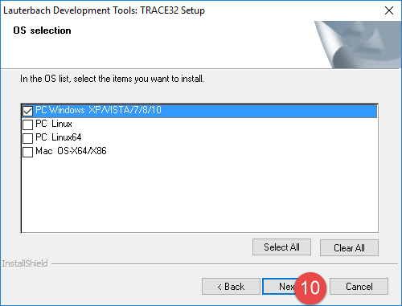
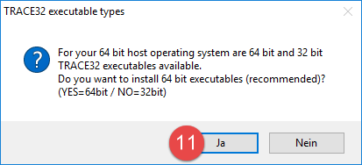
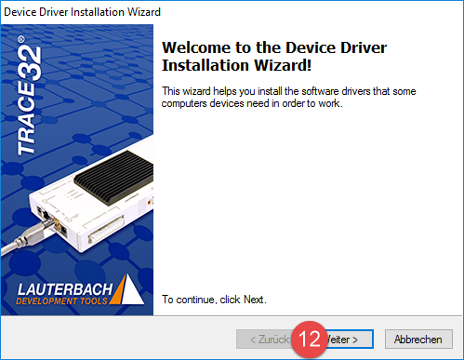

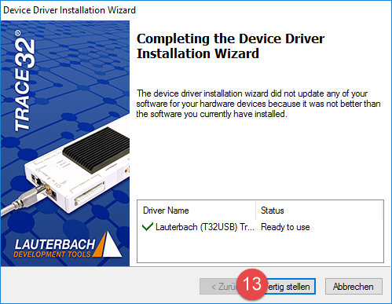
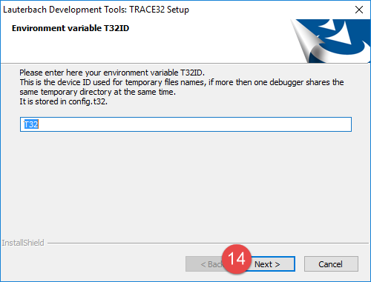

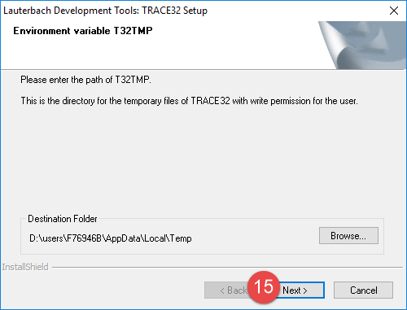
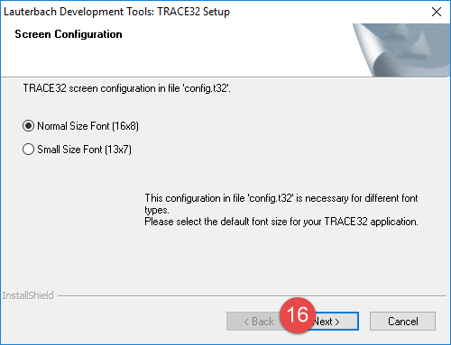

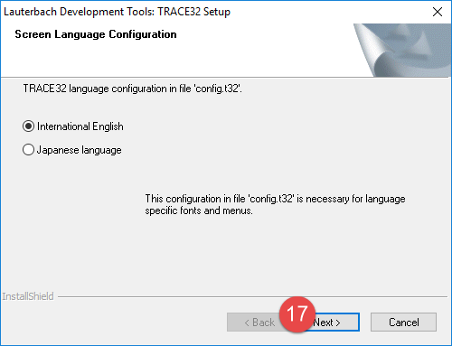
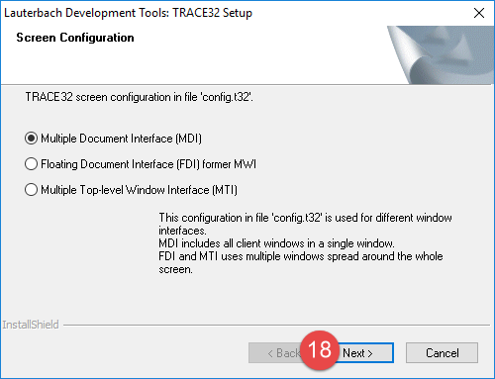

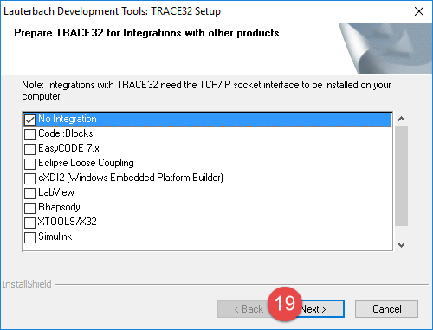
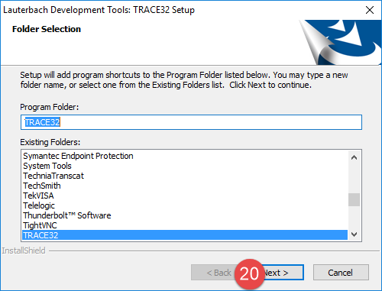
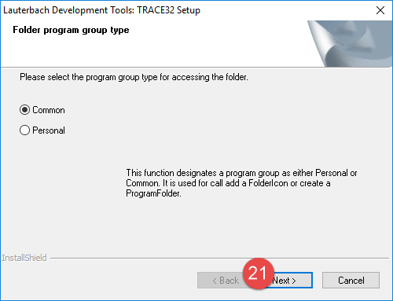
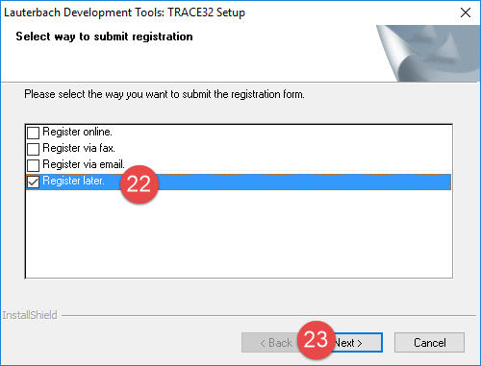

- Step 4: If you already have TRACE32 installed, you should have the C:\T32 directory
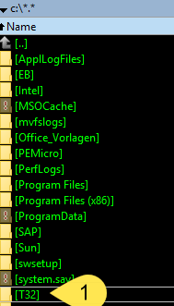

- Step 5: unzipped trace32_n_2020_01_000116390_multiple_20200117114509.zip (\\dereu1nquest1\install\Tools\Lauterbach\Updates\2020_01_17_Update_ARM_TraveoII_RH850\) locally on your machine to C:\T32. (Replace your existing files like a merge operation)

FLM3 TRACE32 startup environment

After successful installation of the Lauterbach T32 software in the C:\T32 directory,
the debug session can be started as follows:
- Connect your Lauterbach uTrace debugger to the FLM3 target system.
- Connect your Lauterbach uTrace debugger to your PC via USB and switch it ON.
- Apply power to your FLM3 target system.
- Make sure to hold the CPU on your FLM3 target system awake, by receiving CAN messages (e.g. from a VECTOR CANoe Restbus simulation).
- Start the T32 debug environment by using either one of the two shortcuts for the different FLM3 High/Low variants:
"W:\FLM3\asr6\Build\ToolsSpecific\Cust\Bw\Bw16\TRACE32\TRACE32_FLM3_High.lnk"
"W:\FLM3\asr6\Build\ToolsSpecific\Cust\Bw\Bw16\TRACE32\TRACE32_FLM3_Low.lnk"
If your FLM3 repository is installed to another directory than “W:\FLM3”, please adapt the given path in the “Start in” Edit-Box of the shortcut properties dialog.
Using this technique, your shortcut can be copied anywhere you want (even on your PC desktop).
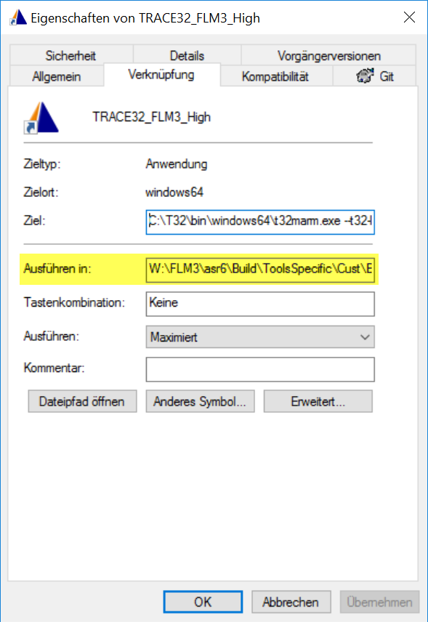
After starting the T32 debugger software, your desktop should look like this:
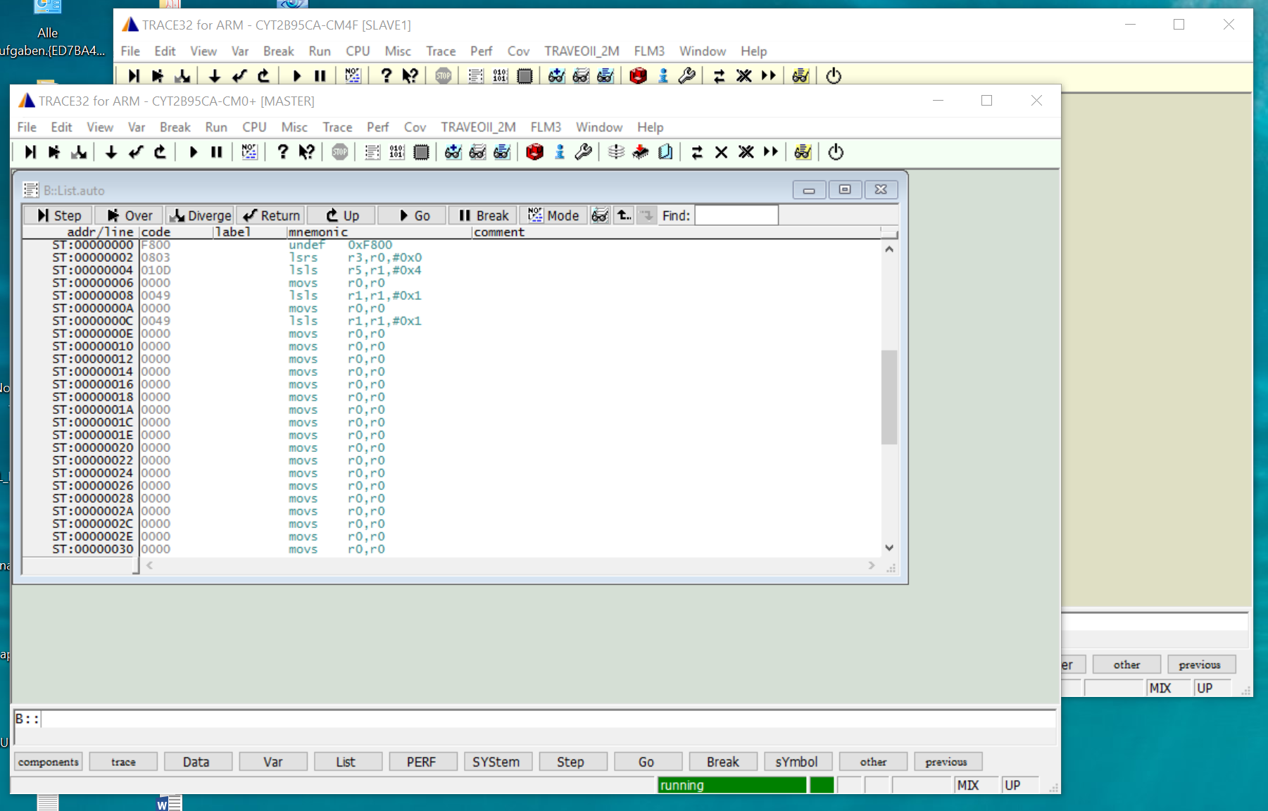
There are two main windows present:
- The green one is showing the Cortex-M0+ core (Master) of your Traveo-II device
- The yellow one is showing the Cortex-M4F core (Slave) of your Traveo-II device
The debugger is now connected to the already running CPU cores on the Traceo-II device
(if there is valid program present in the Code Flash)
In general, the following aspects must be kept in mind:
- Code memory flashing on the Traveo-II device can only be done by the Cortex-M0+ Master core.
- After Reset, at first the Cortex-M0+ Master core is running. The startup sequence in this core will power-up and start the Cortex-M4F core later on.

Flashing of the Traveo-II device

Prepare Flashing:
Select the Flash-Setup dialog on the Cortex-M0+ Master device:
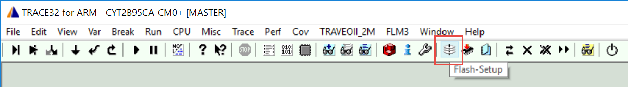
In the Edit-Box of the following “FlashFile Configuration Setup” dialog, the path to a “FlashSetup” file will be possibly shown:
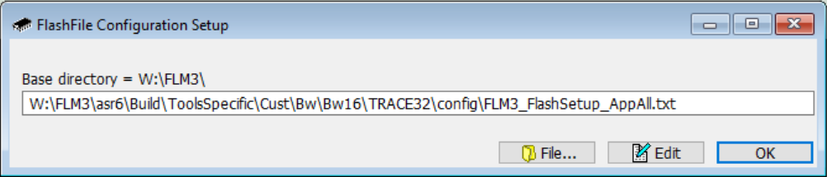
In this FlashSetup file, further information is given about the HEX-files to be flashed into the device and to the ELF-files containing the symbol information for debugging.
A different FlashSetup file can be chosen, by clicking on the the “File…” Button.
The path to this FlashSetup file can either be absolute or relative to the “Base directory” stated above the Edit-Box in this dialog.
The path to this FlashSetup file will be stored internally in a different file on your PC. Next time when you open this dialog, the FlashSetup file selected last will be shown.

The contents of this FlashSetup file can be edited by clicking on the “Edit” button:
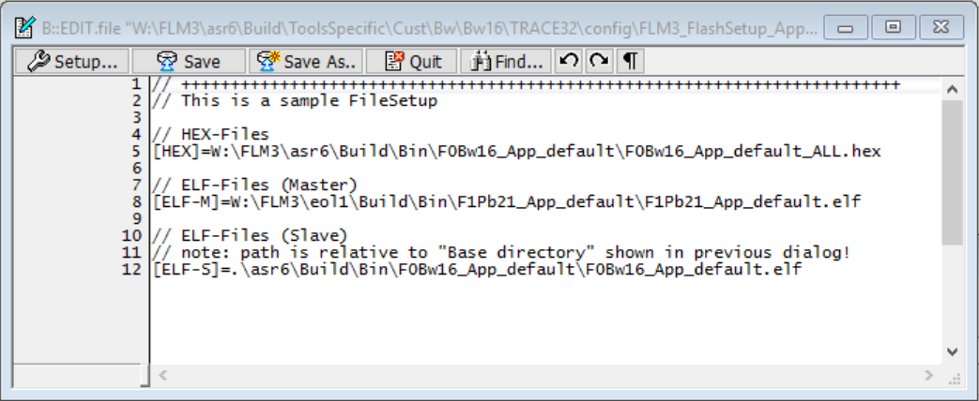
The syntax in this file is as follows:
- Lines starting with “//” are comments
- Lines starting with “[HEX]=” are specifying HEX-Files to be flashed into the Traveo-II device. It is possible to specify more than one HEX-File. All given HEX-Files are flashed into the Traveo-II device in the order from top to bottom.
- Lines starting with “[ELF-M]” are specifying ELF-Files with symbol information to be loaded into the T32 GUI of the Cortex-M0+ Master core.
- Lines starting with “[ELF-S]” are specifying ELF-Files with symbol information to be loaded into the T32 GUI of the Cortex-M4F Slave core.
Save all settings and close the “FlashFile Configuration Setup” dialog by clicking on the “OK” button or close this dialog box without saving by clicking on the red Window-Close button in the upper right corner.

Perform Flashing:
By clicking on the “Flash-ECU” toolbar button, all HEX-Files specified in the FlashSetup file selected last, will be flashed into the Traveo-II device. After this the symbol information of all ELF-Files specified in the FlashSetup file will be loaded into the Cortex-M0+ Master GUI and the Cortex-M4F Slave GUI:
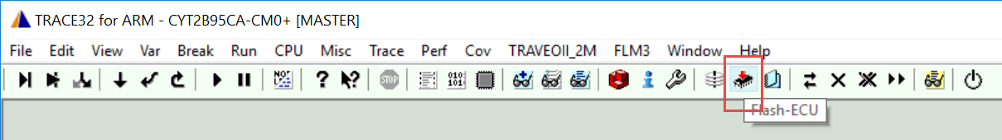

Loading Symbol Information only:
By clicking on the “Load-Symbols” toolbar button, it is possible to load only the symbol information given in ELF-Files specified by the FlashSetup file selected last (without flashing). This is expecially useful, if the Traveo-II flash memory was already programmed with the selected HEX-Files before.
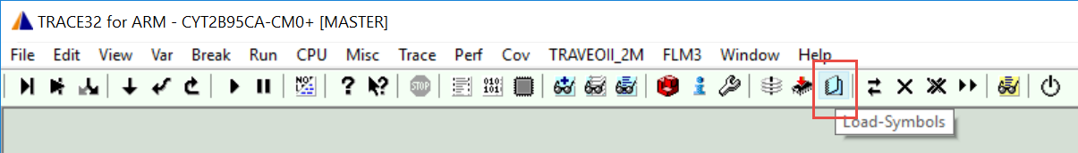

Debugging

Reset and Start

- Starting both CPU cores together
By clicking on the “Start All Cores” toolbar button
  - Both CPU cores will be reset
  - Both CPU cores are started (almost) together and running
This toolbar button is available on both T32 GUI’s (Cortex-M0+ Master Core and Cortex-M4F Slave Core).
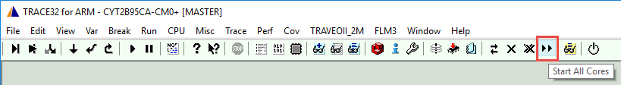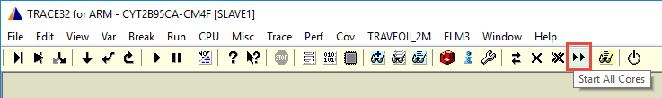

- Preparing both CPU cores together
By clicking on the “Prepare All Cores” toolbar button
  - Both CPU cores will be reset.
  - The Cortex-M0+ Master Core is started until it enables the Cortex-M4F Slave Core.
  - The Cortex-M4F Slave Core is started until it reaches the Application Resetvector.
  - Code execution can now be resumed on both CPU cores separately.
This toolbar button is available on both T32 GUI’s (Cortex-M0+ Master Core and Cortex-M4F Slave Core).
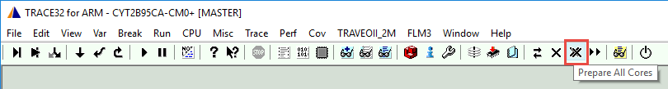
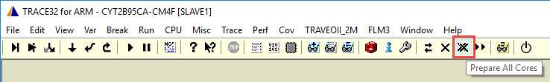

- Prepare Cortex-M0+ Master Core
By clicking on the “Prepare-CM0+” toolbar button
  - The Cortex-M0+ Master Core will be reset
  - The Cortex-M0+ is started until it reaches the Application Resetvector
  - The Cortex-M0+ code execution can now be resumed manually
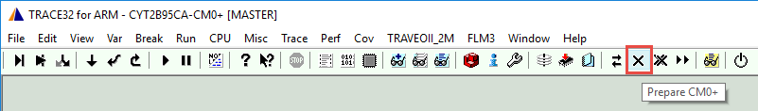
This function is intended to be used for debugging of the Cortex-M0+ Master Core application including the Cortex-M0+ startup process.

- Prepare Cortex-M4F Slave Core
By clicking on the “Prepare-CM4” toolbar button
  - Both CPU cores are reset
  - The Cortex-M0+ Master Core is started and running
  - The Cortex-M4F Slave Core is started until it reaches the Application Resetvector.
  - The Cortex-M4F code execution can now be resumed manually
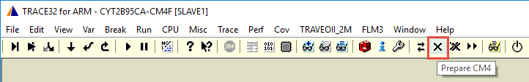
This function is intended to be used for debugging of the Cortex-M4F Slave Core application including the Cortex-M4F startup process.

- Synchronize Go/Break on both Cores
In the dialogbox following this toolbar button, it can be selected if both CPU cores are stopped or started together.
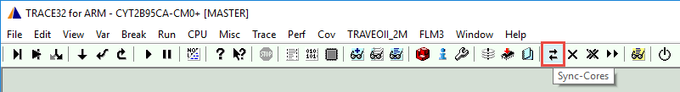
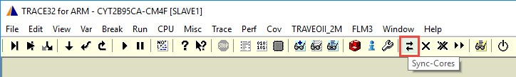

User specific Scripts

OS-Aware Debugging

ITM-Trace

