Contents
1 Preconditions: 1
2 Steps: 2
3 Summary 5
4 Actions 6

History
24.06.2021 | Created Initial Version | Amol Kakade (ALRT/EES3)

Preconditions:
- Open J-Flash application and project ‘H5.jflash’ for Hongqqi H5.
J-Flash project path is –
https://jind.magnetimarelli.com/albitbucket/projects/HQGIF/repos/hqgif/browse/Build/ToolsSpecific/Cust/Hq/Hq001/J-Flash/H5.jflash

- Flash Main application file ‘F02Hq001_App_default_ALL.hex’ (as part of normal application flashing for every new build) using J-Flash.
Note: This is needed by default, i.e. application needs to be available so that coding data takes an effect.

- Select or identify the coding data file to be used from path below –
Note: File type ‘.hex’ are to be used with JFlash.
https://jind.magnetimarelli.com/albitbucket/projects/HQGIF/repos/hqgif/browse/Src/Src_AL/Cust/Hq/Hq001/Exe/CodingData/Release4

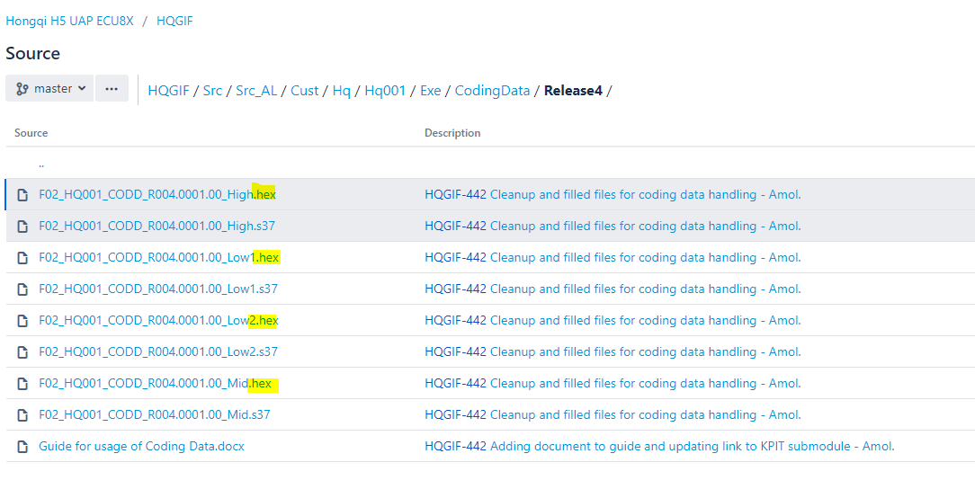

Steps:

Erase only coding data blocks
- Go to ‘Options’->’Project Settings’->Flash
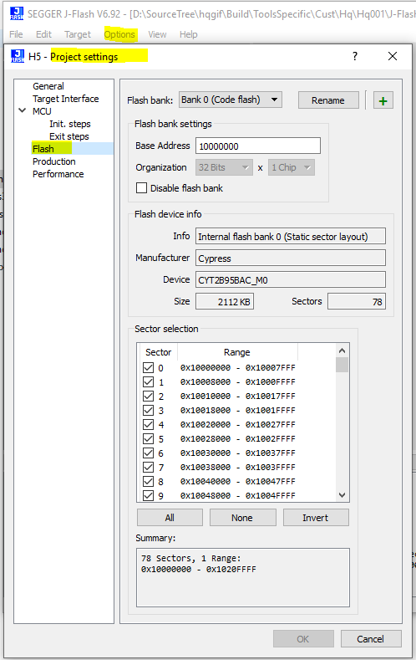

- On pane ‘Sector Selection’ select button ‘None’:->
NOTE: All sectors should be un-selected first.
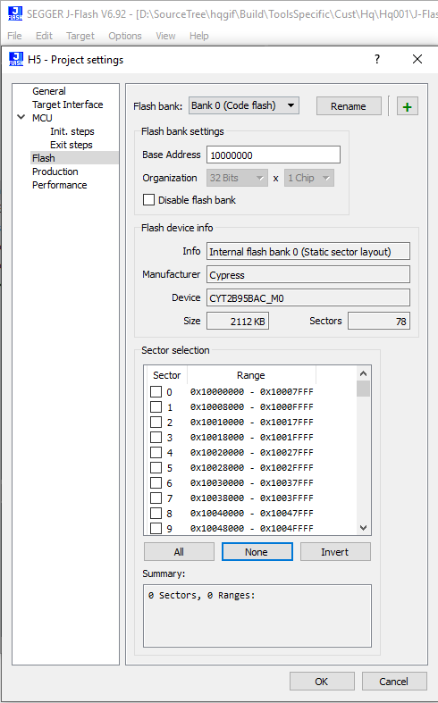

- Select only below 2 sectors from section selection list and press OK –
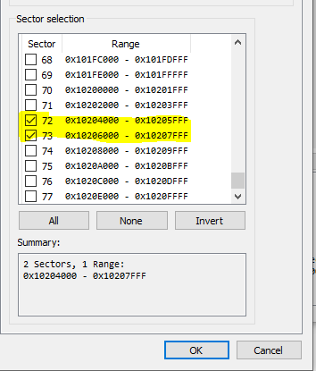
- Connect J flash using menu option: ‘Target’-> ‘Connect’

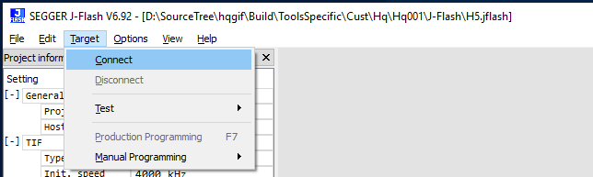

- Erase selected sectors using option from ‘Target’ -> ‘Manual Programming’ -> ‘Erase Sectors’.
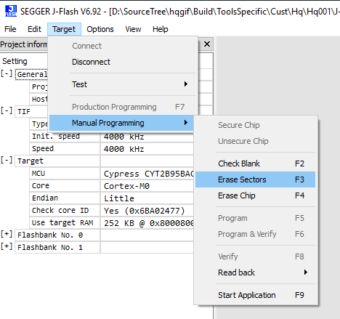
- We Should see below log -
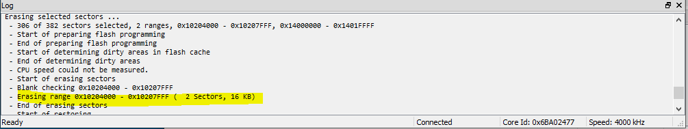

Write Coding Data:
- Open coding data ‘.hex’ file in J flash, or drag and drop corresponding ‘.hex’ file in J-flash.
- Use Manual programming option to ‘Program and verify only’.
Note: DO NOT USE ‘Production Programming’, this will erase main application and flash only coding data without application.
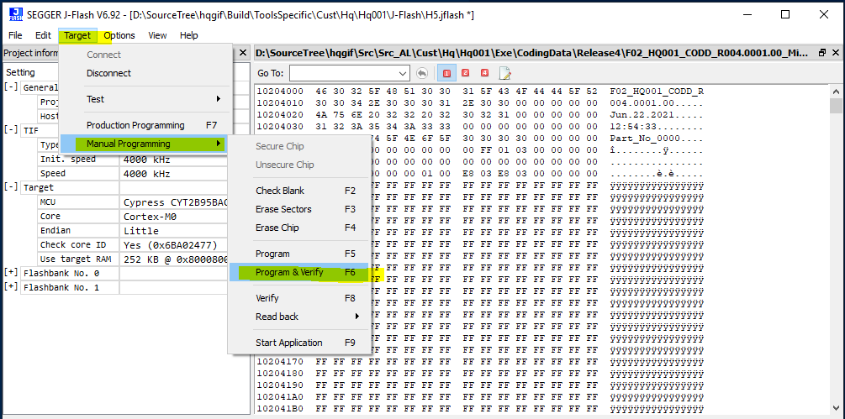

- Coding data will be updated successfully.
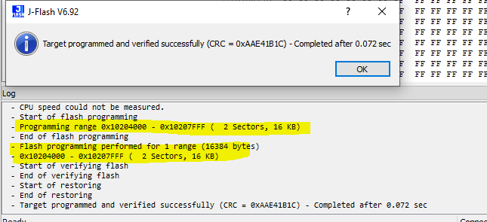

Summary
- Please feel Free to contact me in case of questions or doubts.

Actions

Action | Date | Responsible

